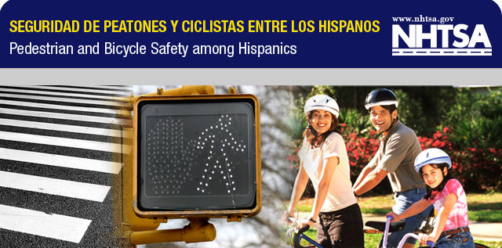

Hispanics at-risk for Pedestrian and Bicycle crashes

Spanish-language Safety Materials Now Available
for Community Based Organizations

When Hispanics come to the United States, they often rely on bicycling and walking as their primary means of transportation, but they often are not familiar with U.S. traffic signs, signals and practices. Language barriers may also affect their ability to understand how to safely travel. For these –and other reasons– Hispanic immigrants are at a higher risk of being involved in pedestrian and/or bicycle safety crashes. Hispanic adult men, in particular, may be at even higher risk.

In an effort to reduce pedestrian and bicyclist fatalities involving Hispanics, the National Highway Traffic Safety Administration (NHTSA) has created free Spanish-language materials that teach Hispanics about basic pedestrian and bicycle rules and regulations.

The materials include posters, brochures and radio public service announcements (PSAs) that can be downloaded by visiting www.nhtsa.gov/links/ped_bike_sp.html. Print copies can also be requested by sending a fax to 301-386-2194 with your name, address, phone number, and number of copies (up to 25 maximum for each) that you want to receive for each item.

